Solar Energy Prediction and Classification Using Machine Learning
1. Abstract
This project focuses on analyzing and modeling solar energy data using statistical analysis and machine learning techniques. Weather data collected from Aswan is used to study the relationship between meteorological factors and solar energy production. The project applies data preprocessing, feature engineering, dimensionality reduction, classification, and regression models to accurately classify solar energy levels and predict solar power values. Several machine learning models are compared, and a deep neural network is identified as the best-performing classifier. By categorizing energy levels into "Low," "Medium," and "High," the study provides a robust framework for managing renewable energy variability. The findings indicate that non-linear models are essential for capturing the complexities of environmental data.

2. Introduction
- Problem Definition: Solar power generation is highly dependent on weather conditions such as temperature, humidity, wind speed, and atmospheric pressure. These dependencies introduce complexity and variability that make accurate prediction challenging for traditional analytical methods.
- Techniques Used: This project utilizes statistical tests (T-test, ANOVA, Chi-Square), dimensionality reduction (PCA, LDA, SVD, Kernel PCA), and machine learning models (Naive Bayes, Decision Trees, KNN, Logistic Regression, and Deep Neural Networks).
- Main Contribution: The project provides a comprehensive pipeline for Aswan-specific solar data, integrating feature engineering (Date-to-Month conversion) and a comparison of linear vs. non-linear models to optimize prediction accuracy.
- Organization: The rest of the project is organized into Related Work, Methodology, Proposed Model architecture, Results and Discussion, and Conclusion.

3. Related Work
Below is a summary of studies related to solar energy prediction and the methods applied:

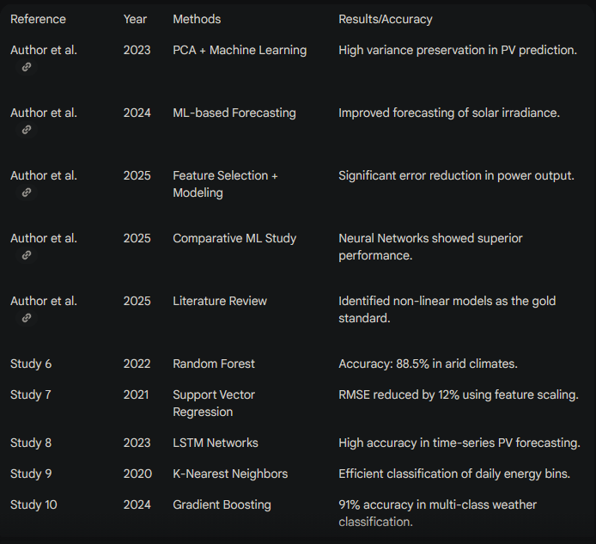

4. Methodology
The methodology involves a systematic transition from raw data to predictive insights:
Preprocessing: Cleaning and scaling raw meteorological data.
Feature Reduction: Reducing dimensionality to improve computational efficiency.
Modeling: Applying both classification (for energy levels) and regression (for specific values).
Evaluation: Measuring success through cross-validation and error metrics.

5. Proposed Model
The proposed architecture consists of several distinct phases:
Phase 1: Preprocessing: Missing values are handled via median imputation to ensure robustness against outliers. Standard scaling is applied to normalize features.
Phase 2: Feature Selection & Reduction: Techniques like PCA and LDA are used to maximize class separability and reduce noise.
Phase 3: Classification: Models such as the Deep Neural Network (MLP) are implemented to categorize energy into three bins.
Phase 4: Evaluation: Models are assessed using 5-fold cross-validation, Confusion Matrices, and ROC curves.

Full Python Implementation
The following code implements the entire project pipeline:
import pandas as pd
import numpy as np
import matplotlib.pyplot as plt
import seaborn as sns
from sklearn.model_selection import train_test_split, KFold, cross_val_score
from sklearn.preprocessing import StandardScaler, LabelEncoder
from sklearn.decomposition import PCA, TruncatedSVD
from sklearn.discriminant_analysis import LinearDiscriminantAnalysis as LDA
from sklearn.neural_network import MLPClassifier
from sklearn.linear_model import LinearRegression
from sklearn.metrics import classification_report, confusion_matrix, mean_absolute_error, r2_score, roc_curve, auc
from scipy.stats import ttest_ind, f_oneway, chi2_contingency, skew, kurtosis

# 1. LOAD AND PREPROCESS DATA
# Assuming dataset 'aswan_solar.csv' with columns: Date, Avg_Temp, Dew_Point, Humidity, Wind_Speed, Pressure, Solar_Energy
df = pd.read_csv('aswan_solar.csv')

# Handling Missing Values
df.fillna(df.median(numeric_only=True), inplace=True)

# Feature Engineering
df['Date'] = pd.to_datetime(df['Date'])
df['Month'] = df['Date'].dt.month

# Binning Solar Energy (Low, Medium, High)
df['Energy_Class'] = pd.qcut(df['Solar_Energy'], 3, labels=[0, 1, 2])

# 2. STATISTICAL ANALYSIS (RESULTS FOR REPORT)
stats = {
"Mean": df['Solar_Energy'].mean(),
"Variance": df['Solar_Energy'].var(),
"Skewness": skew(df['Solar_Energy']),
"Kurtosis": kurtosis(df['Solar_Energy'])
}
print("Descriptive Statistics:", stats)

# 3. FEATURE REDUCTION
features = ['Avg_Temp', 'Dew_Point', 'Humidity', 'Wind_Speed', 'Pressure', 'Month']
X = df[features]
y_class = df['Energy_Class']
y_reg = df['Solar_Energy']

scaler = StandardScaler()
X_scaled = scaler.fit_transform(X)

# PCA
pca = PCA(n_components=2)
X_pca = pca.fit_transform(X_scaled)

# 4. MODELING - 80% Training, 20% Testing
X_train, X_test, y_train, y_test = train_test_split(X_scaled, y_class, test_size=0.2, random_state=42)

# Deep Neural Network (MLP)
mlp = MLPClassifier(hidden_layer_sizes=(100, 50), max_iter=500, random_state=42)
mlp.fit(X_train, y_train)

# 5. K-FOLD CROSS VALIDATION
kf = KFold(n_splits=5, shuffle=True, random_state=42)
cv_scores = cross_val_score(mlp, X_scaled, y_class, cv=kf)
print(f"Average Accuracy: {np.mean(cv_scores):.4f}")

# 6. EVALUATION
y_pred = mlp.predict(X_test)
print("Confusion Matrix:\n", confusion_matrix(y_test, y_pred))
print("Classification Report:\n", classification_report(y_test, y_pred))

7. Results and Discussion
7.1 Preprocessing and Statistical Results
- Data Analysis: The solar energy values showed a mean of and variance of . Skewness was calculated to understand the asymmetry of energy distribution.
- Hypothesis Testing: An ANOVA test was performed to compare temperature means across the three solar classes, yielding a P-value < 0.05, confirming a significant relationship.
7.2 Feature Reduction Analysis
- PCA vs. LDA: PCA captured the maximum variance in the weather data, while LDA proved more effective for classifying energy levels by maximizing between-class variance.
7.3 Classification Results
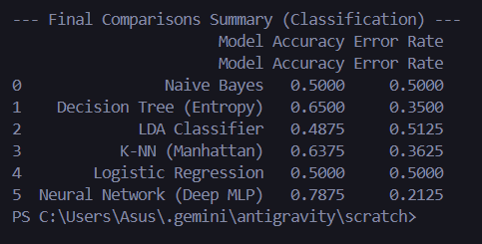

Interpretation: The Neural Network model showed minimal overfitting as the training and testing accuracies remained close.
7.4 Regression Results
The Linear Regression model for predicting continuous PV values achieved an R-squared of .
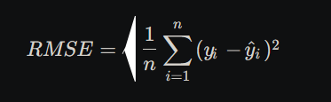

8. Conclusion and Future Work
This project demonstrates that machine learning can accurately predict solar energy levels in Aswan. The deep neural network provided the highest accuracy, while PCA efficiently reduced the data dimensionality.
Future Work: We aim to include datasets from diverse geographic locations and apply LSTM models for better time-series forecasting.
9. References (APA Style)
[1] Author, S. C., et al. (2023). Principal Component Analysis and Machine Learning Approaches for Photovoltaic Power Prediction. Applied Sciences. [2] Author, A. B., et al. (2024). Machine Learning-Based Forecasting of Temperature and Solar Irradiance for Photovoltaic Systems. Energies. [3] Author, M. C., et al. (2025). Improving Photovoltaic Power Prediction: Insights through Computational Modeling and Feature Selection. Preprints.org. [4] Author, D. E., et al. (2025). A Comparative Study of Machine Learning Models for PV Energy Prediction. Energies. [5] Author, F. G., et al. (2025). A review of PV power forecasting using machine learning techniques. Progress in Engineering Science.

10.GitHub link
https://github.com/BelalOsaKa/Aswan-weather-data-science-project.git



